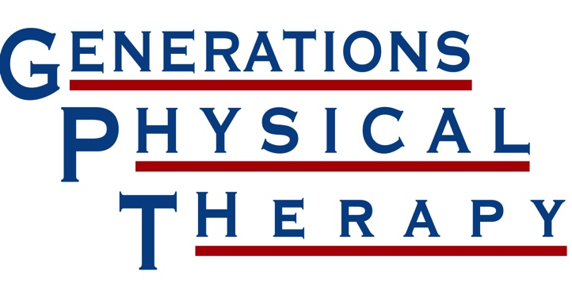
Concussion Order

Travis Tarr, DPT, Director of Concussion & Rehabilitation Services t.tarr@generationspt.com www.generationspt.com

Name: Date:

Diagnosis: Precautions:

Date of Concussion: Sport Returning to:

Frequency: times/week Duration: 1 2 3 4 5 6 Other:

Baseline Performed: O Yes O No If Yes, Location Performed:

☑ Physical Therapy Evaluation and Treatment (order specific to ImPACT trained therapist)
О Impact Computerized Neurocognitive Testing
О Baseline O Post-Concussion Test (initial) O Post-Concussion Re-Test
O Physician to Re-test O Frequency or Date of Re-test:

О Vestibular Rehabilitation
O Physician Follow up Required Prior to Protocol Progression
O Progress Appropriately as per Protocol
O Other:

O Exertion Protocol
O Stage 1 (30-40% HR Max)
O Stage 2 (40-60% HR Max)
O Stage 3 (60-80% HR Max)
O Stage 4 (80% HR Max) Sport Specific
O Stage 5 (80-100% HR Max) Sport Specific

О Aquatic Rehab Center
О Include Hydroworx

Scheduled Follow Up: Physician:

WV Concussion Institute is located and operated by Generations RC. Inc.
Present this order at your scheduled appointment at the location nearest you
Barboursville: 304-733-9560 Hurricane: 304-757-2500 Winfield: 304-586-4200
Milton: 304-743-6995 Grayson: 606-474-7649

d

